# Redefining a View with CREATE OR REPLACE

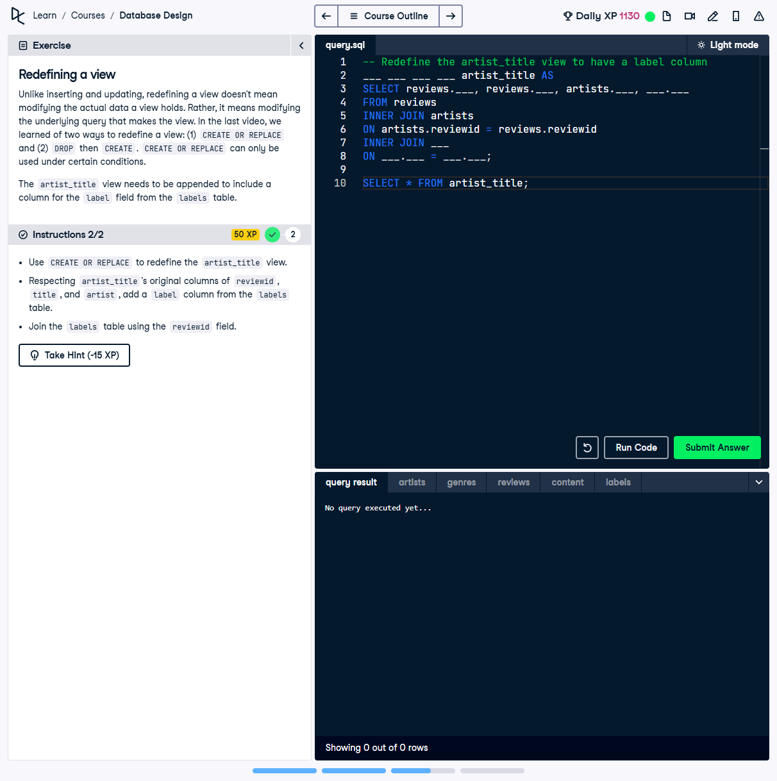

## Question:

Use `CREATE OR REPLACE` to redefine the `artist_title` view while preserving its existing columns (`reviewid`, `title`, and `artist`) and adding a `label` column from the `labels` table. Join the `labels` table using the `reviewid` field.

## Full Answer (SQL Code):

-- Redefine the artist_title view to have a label column  
CREATE OR REPLACE VIEW artist_title AS  
SELECT reviews.reviewid, reviews.title, artists.artist, labels.label  
FROM reviews  
INNER JOIN artists  
ON artists.reviewid = reviews.reviewid  
INNER JOIN labels  
ON labels.reviewid = reviews.reviewid;  
  
-- Output the redefined view  
SELECT * FROM artist_title;

## Explanation of the Answer:

The `CREATE OR REPLACE VIEW` statement redefines the `artist_title` view by including the `label` column. It joins the `reviews`, `artists`, and `labels` tables using `reviewid`. The existing columns remain unchanged, and the new column is added at the end, which is required for view redefinition.